***Name:*** Salama Khaled Abdel-salam

***B.N:*** 355

***Topic*** *:* Computer Engineering Role in COVID-19 Pandemic?

***Github link:***

***Github pages link:***

***Source Code :***

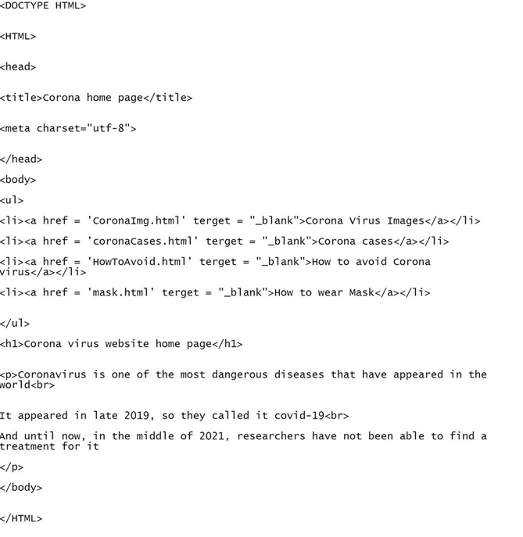

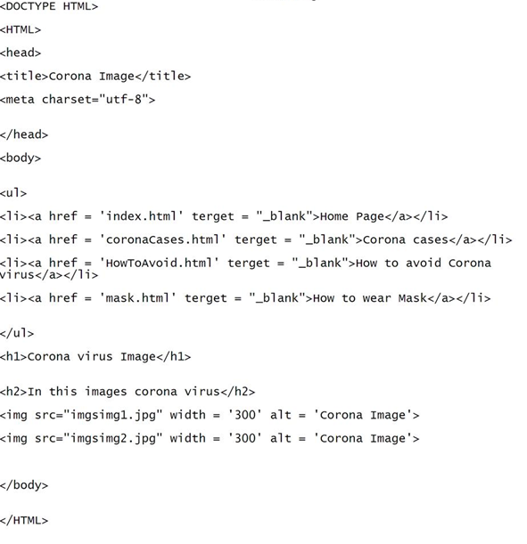

***Screenshots:***

